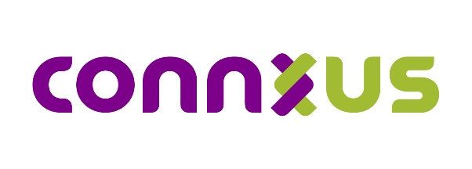
Connxus Data Release Request Project Summary

Requestor:

Project Overview Narrative:

Benefit to Patients and Community Partners:

ICC Participants Requested to Contribute Data (for Connxus use only)
​​☐​ Fully Identifiable Data Set | ​​☐​ Limited Data Set (LDS) | ​​☐​ De-identified Data Set

Data Details:
Date Range:
Encounter Type:
Location:
Demographics:
Diagnoses :
Insurance:
Point of Care:
Procedures:

Request Status (for Connxus use only):

Request Received Date:
​​☐​ Approved | ​​☐​ Denied | ​​☐​ Contingent (Requires additional conditions or requirements)

Status Details:

Required Agreements and Documents (for Connxus use only)
​​☐​ DUA Signed: | ​​☐​ Current BAA | ​​☐​ Current PA | ​​☐​ IRB Approval

Agreements and Documents Details:

